

**COURSE NAME: FIN-PRO**

**SKILL OFFERING ID: 2293**

**PROJECT TITLE: ANALYZE EMERGING TRENDS AND TECHNOLOGIES IN THE INDIAN FINTECH**

**COLLEGE NAME: CARE COLLEGE OF ARTS AND**

**SCIENCE, TRICHY**

**COLLEE CODE: BDU597**

**PROJECT SUBMITTED TO: NAANMUDHALVAN**

**YEAR: 2023**

**DEPARTMENT: DEPARTMENT OF COMMERCE (CA)**

**SEMESTER: 5th SEMESTER**

**GROUP NUMBER:**

**MEMBERS OF THE GROUP: 1. A. KARTHIKEYAN**

**2. S. HARIHARAN**

**3. S. KISHORE**

**GUIDED BY: Mr. M. RADHAKRISHNAN- TUTOR**

**Asst. Professor, Dept of Commerce (CA)**

**SPOC NAME: Mr. M. DEVENDIRAN**

I would like to express my sincere gratitude to Tutor Mr.M. Radhakrishnan for their valuable support, guidance, and assistance throughout analyze Emerging Trends and Technologies in the Indian Fintech.

I wanted to extend my appreciation to my mentor for their guidance and expertise. Your insights were invaluable in shaping this project.

I am also thankful to all those who offered their expertise, time, and encouragement during this endeavor. Your collaboration and insights were invaluable.

This project would not have been possible without the collective effort and dedication of everyone involved. I am truly appreciative of your contributions.

Thank you once again for your unwavering support.

Table of Content

Title Page no

1. Introduction to Indian Fintech and BSFI 4

2. Industry Scenario 5

3. Inter-Ministerial Steering Committee on   
 Fintech (IMSC)

4. Emerging trends in Indian Fintech sector 6

5. Problems Analysis 8

6. Finding Suggestion and Conclusion 9

7. Bibliography 10

8. Fintech Report 2022 11

9. Analyst Opinion 14

**What is FinTech?**

Fintech or Financial Technology innovation, means offering financial services over the internet. It also means solutions or products designed to help your financial matters differently.

**BFSI – Fintech and Financial Services in India:**

India has the highest FinTech adoption rate globally of 87% which is significantly higher than the Global average rate of 64%.

**India – A Global FinTech Superpower**

India is amongst the fastest growing Fintech markets in the world. Indian Fintech industry’s market size is $50 Billion in 2021 and is estimated at $ 150 Billion by 2025.

The Indian Fintech Industry’s Total Addressable Market is estimated to be $1.3 Trillion by 2025 and Assets Under Management and Revenue to be $1 Trillion and $200 billion by 2030, respectively:

**Major segments under Fintech include Payments, Digital Lending, Insur Tech, WealthTech.**

* The payments landscape in India is expected to reach $100 Trillion in transaction volume and $50 Billion in terms of revenue by 2030.
* India digital lending market was worth $270 Billion in 2022 and is expected to reach $350 Billion by 2023.
* India is the 2nd largest Insurtech market in Asia-Pacific and is expected to grow by !5X to reach $88.4 Billion by 2030; India is poised to emerged as one of the fastest growing insurance markets in the world.
* The Indian WealthTech market is expected to grow to $237 Billion by 2030 on the back of a growing base of retail investors.

**10 Bn+**  **75%** **25**   **$34 Bn**

Monthly volume or Of all retail digital Fintech Unicorns Fintech Funding (2014-2022)  
Digital payments payments is India is UPI

Industry Scenario

**Fintech Funding and Valuation:**

The Fintech sector in India has witnessed funding accounting to 14% share of Global Funding. India ranks 2nd on Deal volume. The Fintech Market Opportunity is estimated to be USD 2.1 Trillion by 2030. Indian fintechs were the 2nd most funded startup sector in India in 2022. Indian Fintech startups raised USD 5.65 Billion in 2022. The total number of unique institutional investors in Indian fintech almost doubled between 2021 and 2022, rising from 535 to 1019 respectively.

**Digital Payments:**

* Volume of UPI transactions increased 200X from January 2017 (4.5 Million) to January 2023 (10 Billion) and the value increased 600X during the same period.
* UPI recorded the highest ever volume of transactions in April 2023 – 8.8 Billion.
* Daily transactions on the UPI platform can touch 1 Billion by 2025.
* Digital Payments increased by 76% in transactions and 91% in value (2022).
* A pan-India digital payments survey (covering 90,000 respondents) revealed that 42% of respondents have used digital payments.
* Acceptance of digital payments infrastructure has increased from 170 Million touch points to 260 Million touch points (increase of 53%).

**Inter-Ministerial Steering Committee on Fintech (IMSC):**

A Steering Committee was set up under the chairmanship of then Secretary, DEA on 05.03.2018 to consider various issues relating to development of fintech space in India with a view to make fintech related regulations more flexible and vis-à-vis other emerging economies. The Committee submitted its report to the Finance Ministry on 02.09.2019.

An Inter-Ministerial Steering Committee (IMSC) was set up in Department of Economics Affairs (DEA), Ministry of Finance, to carry on the tasks of implementing the report, including exploring and suggesting the potential applications in government financial processes and applications, particulary accounting and assest management, welfare services, taxation, and handling citizen grievances.

IMSC has been meeting on continuous basis since the release of Report to implement its mandate. So far, IMSC has met 5 times to discuss development across FinTech.

**Joint Working Groups on Fintech (JWG):**

Joint Working Groups have been established with UK and Singapore to improve regulatory connect, adopt learnings and best practices and boost entrepreneurship and collaboration between the nations and promote joint development of Fintech Solution, Interoperability Standards, and Payments Linkages.

UK-INDIA:

The UK and India have built a strong partnership on Fintech. The UK-India Fintech Joint Working Group met most recently in March 2020 and agreed to collaborate on acilitating the flow of faster and cheaper UK-India remittances. In particular, we agreed to work together to explore potential options for greater connectively between India’s Unified Payments Interface system and the UK payments system, and to support greater acceptance of Rupay cards in the UK.

SINGAPORE-INDIA:

The Joint Working Group on Fintech between India and Singapore has been constituted for cooperation in the area of Fintech between the two countries.

Collaboration of India with Singapore will benefit both India and Singapore to excel in the fields of Development of Application Programming Interfaces (APIs), Regulatory Sandbox, Security in payment and digital cash flow, integration of Rupay-Network for Electronic Transfers (NETS), UPI-FAST payment link, AADHAR stack and e-kyc in ASEAN region and cooperation on regulatioin, solutions for financial markets and insurance sector and sand box models.

### Emerging trends in Indian Fintech sector: 1. Open Banking (or BaaS, Banking as a Service):

Open banking is among the hottest fintech trends in the industry. It enables secure data sharing and collaboration between financial institutions, technology companies, and customers. Users can allow their financial data to be accessed by authorized third-party service providers and leverage personalized solutions such as budgeting apps, investment platforms, and loan marketplaces. Facebook and Instagram are leading this fintech trend with services like marketing and shopping, but many others are in line. Open banking has been widely recognized and well-integrated into financial ecosystems over the past few years and will continue to be among the top fintech trends in 2023 and after.

### 2. Embedded Finance:

* Embedded Finance involves fluidly incorporating financial services and products into non-financial platforms, like e-commerce websites, mobile apps, or other digital landscapes. Technological advancements, such as Application Programming Interfaces (APIs) and cloud computing, have contributed to the rapid growth of embedded finance.
* Various industries, including e-commerce, ride-sharing, healthcare, and social media platforms, are assimilating embedded finance to offer a more comprehensive [customer experience](https://www.squadstack.com/blog/10-roles-and-responsibilities-of-customer-care-executive-in-a-bpo).
* Open banking users globally are expected to increase at an average annual rate of about 50 percent from 2020 to 2024. In the year 2020, there were 24.7 million open banking users globally, and this figure is poised to reach 132.2 million by 2024.

### 3. Internet of Things (IoT):

* Internet of Things, or IoT, refers to the network of physical objects or "things' equipped with internet connectivity, software, and sensors. Without human interference, these devices collect and exchange data in real-time and perform specific actions, including financial transactions, fraud detection, and credit scoring.
* As one of the most revolutionary fintech trends, Iot has expanded the reach of financial services, [achieving enhanced customer satisfying experiences](https://www.squadstack.com/blog/achieving-customer-satisfaction), and facilitated innovative solutions. IoT's impact on the fintech industry growth is poised to increase manifold in the upcoming years.

### 4. Artificial Intelligence and Machine Learning:

* AI and ML are one of the major key trends in fintech. Artificial Intelligence (AI) refers to stimulating machines with human intelligence and enabling them to perform functions that need human reasoning. Machine Learning (ML) is a subset of AI that allows devices and systems to learn from data using algorithms and improve without explicit programming.
* The fintech industry has leveraged AI and ML to automate tasks such as managing client data, detecting human errors, recommending management strategies, preventing fraud, and performing quality checks. Chatbots and self-learning apps can provide insights into customer behavior and help improve financial services. AI is also used for checking the [quality in Business Process Outsourcing](https://www.squadstack.com/blog/quality-in-bpo-business-process-outsourcing).
* As of 2023, the AI in Fintech Market size is approximately USD 42.83 billion and is forecast to reach USD 49.43 billion by 2028, with a CAGR of 2.91% during the forecast period (2023-2028).

### 5. Neobanking:

* Online banks that operate without physical branches are among the growing fintech trends in India. These digital-only banks, also known as Neobanks, offer everything a traditional bank offers: online account opening, virtual bank cards, instant payments, budgeting tools, and much more.
* According to research, the global market size of Neo and Challenger Banks was USD 18,604 million in 2018, which is expected to increase at a CAGR of 46.5% and reach USD 1394,648 million by 2026.

**Problems on Fintech**

**The Challenges**

Fintech companies, which use cutting-edge, innovative technology to improve and automate financial services, have faced several challenges in the current economic climate.

**The pandemic effect**

One of the primary challenges is the uncertainty caused by the Covid-19 pandemic. In addition, the sudden and severe economic downturn has led to a decline in consumer spending and increased uncertainty for businesses, making it difficult for fintech companies to predict and plan for future growth and ventures.

**Regulatory challenges**

Another challenge for fintech companies is the increased regulatory scrutiny. As these companies become more mainstream and disrupt traditional financial institutions, regulators have begun to take a closer look at their operations to ensure they comply with laws and regulations. These stringent regulation and compliance requirements can lead to added costs and delays for fintech companies, making it difficult to compete with established financial institutions.

**Market Saturation**

Fintech companies also face intense competition from traditional financial institutions, which have embarked on a similar path by adopting similar technologies and business models to stay competitive. As a result, it is making it difficult for fintech companies to differentiate themselves in the crowded fintech market to attract and acquire customers.

**Cyber Security**

Additionally, Fintech companies also face challenges related to cybersecurity and data privacy. As they collect and store sensitive financial data, they are at a higher risk of cyber-attacks and data breaches. Such adversaries can lead to reputational damage, legal liabilities, and financial losses if they fail to protect their customers’ data.

**Solution**

If one wants to run a FinTech company, then one must know the market needs and research for the factors which can influence financial behavior, the consumer behavior. The most crucial aspect of building great customer relationships is providing quality service.

As regard to the potential risks and their mitigation, RegTech and SupTech have an important role. RegTech is an application which makes compliances efficient through the automated processes and focuses on technologies that facilitate regulatory requirements. On the other hand, SupTech is a technology that is used by the regulators to support supervision, and monitors things like KYC, AML, CFT etc. Examples are – IDPMS (Import Data Processing and Monitoring System. There can be many software’s which can detect frauds and thefts. While its advancements are disruptive, the focus of any Fintech company should be about educating people about the concept.

**Conclusion**

Despite these challenges, many fintech companies have been able to adapt and continue to grow. Some have taken advantage of the increased demand for digital financial services during the pandemic, while others have shifted their focus to digital payments and lending. However, for fintech companies to succeed in the current economic climate, they will need to be able to navigate these challenges and find ways to stay competitive.

The current economic climate has presented several challenges for fintech companies, including uncertainty caused by the pandemic, increased regulatory scrutiny, competition from traditional financial institutions, and cybersecurity concerns. Yet, despite these challenges, fintech companies have the potential to thrive by being able to navigate these challenges and find ways to stay competitive in the market and grow.

**Bibliography**

**Website:**

1. <https://community.nasscom.in/communities/digital-transformation/bfsi/indian-fintech-ecosytem-key-challenges-and-how-to-deal-with-it.html#:~:text=In%20Fintech%20there%27s%20a%20Big,most%20of%20the%20urban%20people>.
2. <https://bfsi.economictimes.indiatimes.com>
3. <https://www.nseindia.com>
4. <https://www.forbes.com/sites/forbesbusinesscouncil/2022/07/29/the-rise-and-evolution-of-fintech-post-covid/>
5. <https://www.sciencedirect.com/science/article/pii/S1042957321000462>
6. <https://globalfintechseries.com/featured/analytical-study-on-the-indian-fintech-domain-post-covid/>

Reports of Indian Fintech 2022:

**Fund Decline in 2022:**  
 In the first half of 2022, the market witnessed a sharp decline in equity FinTech funding. As of 30 June 2022, total FinTech funding raised (excluding debt, Grant, Post-IPO and ICO funding, and corporate minority/majority rounds) stood at $2.47 billion. Several factors could have played a role in this decline, including macroeconomic and geopolitical factors such as the Ukraine war, increase in inflation, and uninspiring financial and public market performance of major FinTech companies, creating a dent in investors’ confidence in the future exit prospects.

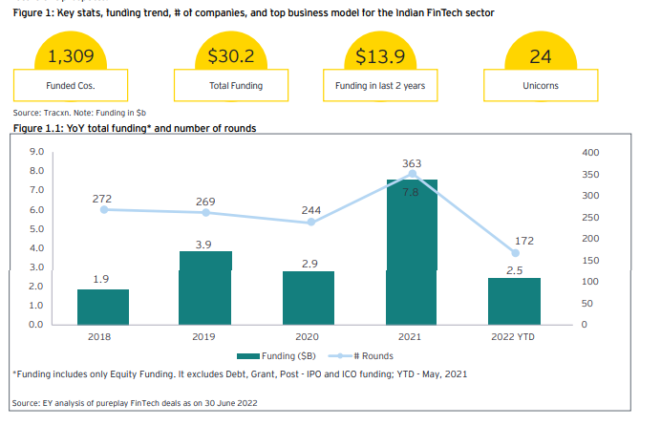

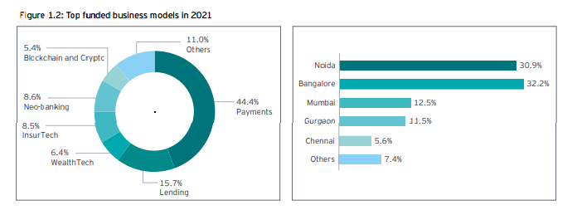

As of June 2022, India had more than 100 unicorns, and in this prestigious pool of startups, almost every fourth unicorn is a FinTech. But there is a lot of headroom compared to global FinTech unicorns; India lags and contributes approximately 7% of the global pool of FinTech unicorns. Considering the market size, we should expect more.

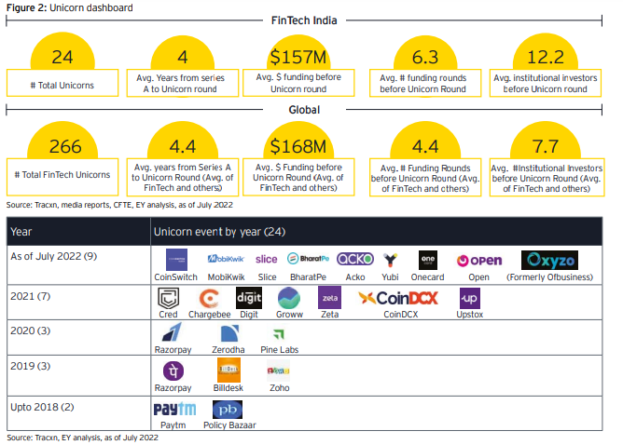

This report analyzes key FinTech segments in depth to understand the areas of growth, opportunity, and challenges. Below is an indicative illustration of the wide and diversified FinTech landscape in India:

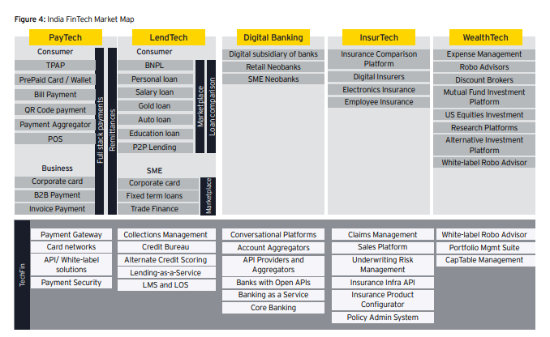

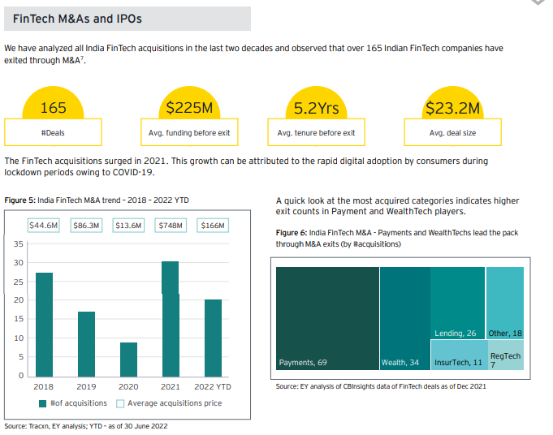

**Upcoming growth in India Fintech sector:**

* The largest market will be Digital Investment with a AUM of US$777.10m in 2023.
* The average AUM per user in the Digital Investment market is projected to amount to US$26.70 in 2023.
* The Digital Investment market is expected to show a revenue growth of 23.1% in 2024.
* In the Digital Payments market, the number of users is expected to amount to 1,082.00m users by 2027.
* Total AUM in the Digital Investment market is projected to US$777.10m in 2023.
* The distinctive characteristics of KPIs within the FinTech sector preclude their combination and presentation as a singular number representative of the whole FinTech industry.

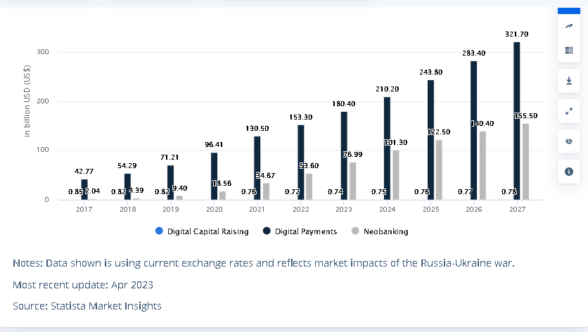

Transaction value by Segment

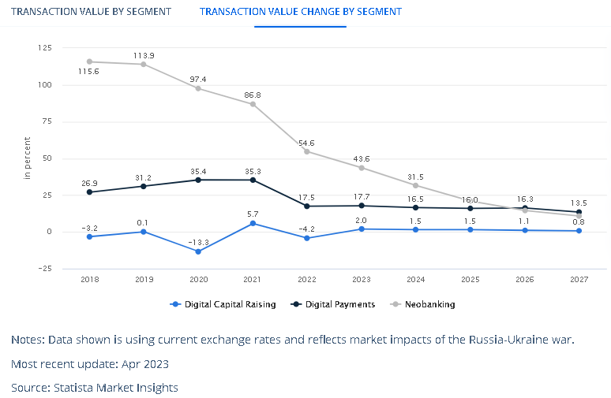

Transaction Value Change by Segment

## **Analyst Opinion:**

The fintech market is rapidly evolving, with digital payments, digital investment, digital capital raising, digital assets, and neobanking emerging as some of the most significant trends. Digital payments have seen an unprecedented surge in popularity, with consumers increasingly relying on mobile payment solutions for their day-to-day transactions. Digital investment platforms are also gaining traction, with individuals seeking low-cost and easy-to-use investment options. Additionally, digital capital raising has become an attractive option for startups and SMEs, as it provides an efficient way to access funding. The rise of digital assets, such as cryptocurrencies and NFTs, has also created new opportunities for investors and traders. Finally, neobanks have disrupted the traditional banking industry by providing innovative, customer-centric solutions that cater to the needs of today's digital-savvy consumers.  
The growth in the fintech market is driven by several factors. Firstly, the increasing adoption of smartphones and the internet has made digital solutions more accessible to consumers, leading to a surge in demand for fintech services. Secondly, the COVID-19 pandemic has accelerated the shift towards digital payments and investments, as consumers have had to adapt to remote and contactless transactions. Thirdly, regulatory changes have enabled fintech companies to compete with traditional financial institutions on a more level playing field. Finally, advancements in technology, such as AI and blockchain, have opened up new possibilities for fintech innovation, driving further growth in the market.  
The fintech market is expected to continue its rapid growth trajectory, driven by ongoing technological advancements, changing consumer behavior, and regulatory support. Digital payments are likely to remain a dominant trend, as consumers increasingly prefer the convenience and speed of mobile payment solutions. Digital investment platforms are also expected to grow in popularity, as more individuals seek to manage their finances online. Additionally, the rise of digital assets and neobanking is likely to continue, as these trends reshape the financial landscape. Overall, the fintech market is expected to remain dynamic and innovative, with new solutions and services emerging to meet evolving consumer needs.

Thank you